**Tutorial documentation**

**1. Learning objectives**

In this course, we mainly learn to use STM32F103RCT6 and fingerprint recognition module module to realize fingerprint recognition function.

**2. Prepare before class**

The fingerprint recognition module adopts UART communication, and the RX and TX of the module are connected to the PA2 and PA3 pins of the STM32F103RCT6 board, respectively. V+/Vi and GND are connected to the 3.3V and GND of the STM32F103RCT6, respectively.

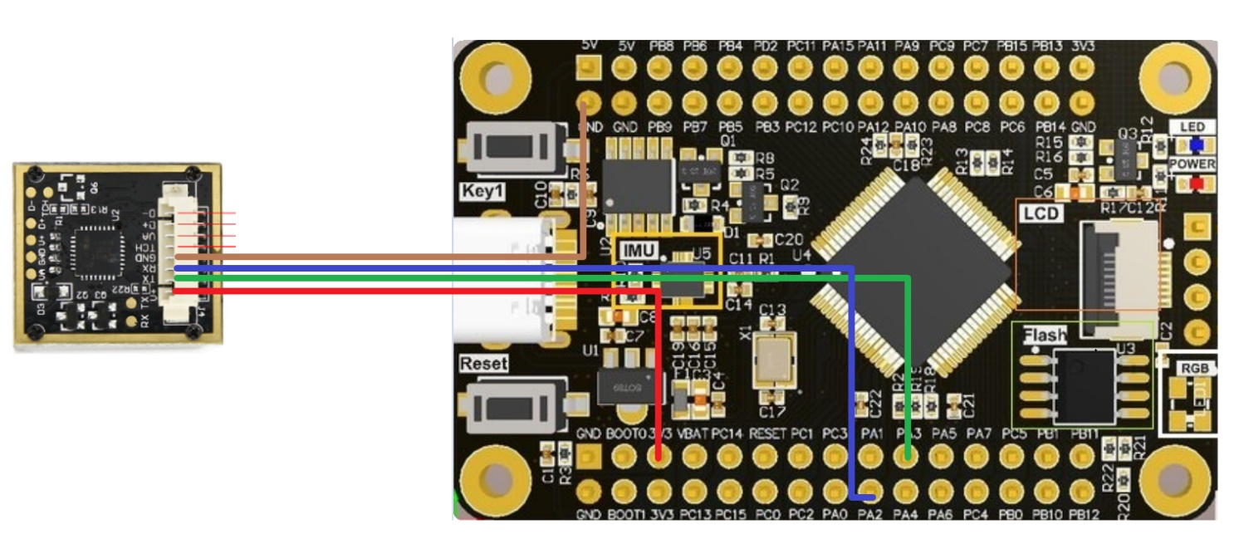

Note: module communication baud rate 57600, if not, please use 9. host computer test software SYDemo.exe modify the baud rate, the specific method can refer to 9. upper computer test software ATK-AS608 fingerprint recognition module user manual .pdf section 2.5.1 section 1~4 steps. Or modify the usart2_baund in the program.

1. **Program**

The baud rate of the module is 57600.



Initialize interrupt, delay, serial port 1, and serial port 2.

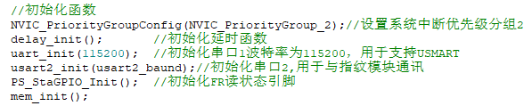

The serial port prints and starts testing and connecting the module.

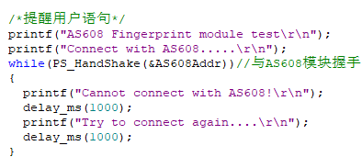

After the module is successfully connected, Connect Success is displayed and information such as baud rate and fingerprint number are printed.

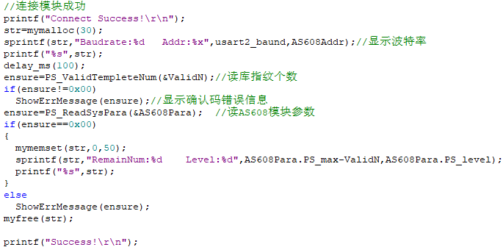

Loop to receive serial port data.

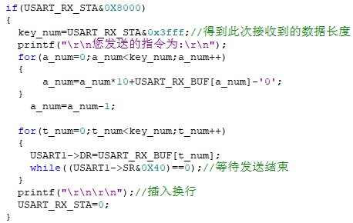

If the serial port data is recognized, 1 enters the fingerprint deletion function, and if it is recognized 2, it enters the fingerprint recording function.

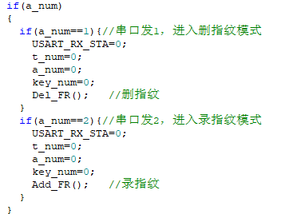

Fingerprint recognition is performed all the time.



**4. Experimental phenomenon**

Run the program after downloading, open the serial port baud rate set to 115200, serial port print AS608 Fingerprint module test, Connect with AS608..... Twice, after the connection is successful, Connect Success! is displayed, and if it is unsuccessful, please check the wiring or baud rate. After the connection is successful, display the baud rate, address, limited number of fingerprints, maximum fingerprint capacity, comparison level and other information, and finally display Success!, press the fingerprint, if there is a matching fingerprint to display the fingerprint ID and matching score, if not, it shows that no fingerprint has been searched.

Send 2 to the serial port, enter the fingerprint recording mode, serial port printing, please press your finger! , press the finger, display the fingerprint correctly after successful reading, serial port printing press the finger again, press the finger, display the fingerprint correctly after successful reading, and then automatically compare the fingerprint twice, the fingerprint is similar to the fingerprint template and prompt the fingerprint storage ID, send a number to the serial port to set the storage ID, after sending, the serial port returns the number of IDs received, the fingerprint begins to store, and then prompts to add the fingerprint successfully and the remaining fingerprint number, exit the fingerprint recording mode. Note: After entering, if you do not press your finger for many times, you will automatically exit the fingerprint recording mode.

Send 1 to the serial port, enter the fingerprint deletion mode, send the fingerprint location to the serial port, after sending, the serial port returns the number of IDs received and starts to delete, end the display fingerprint deletion success and the number of fingerprints left, exit the fingerprint deletion mode.